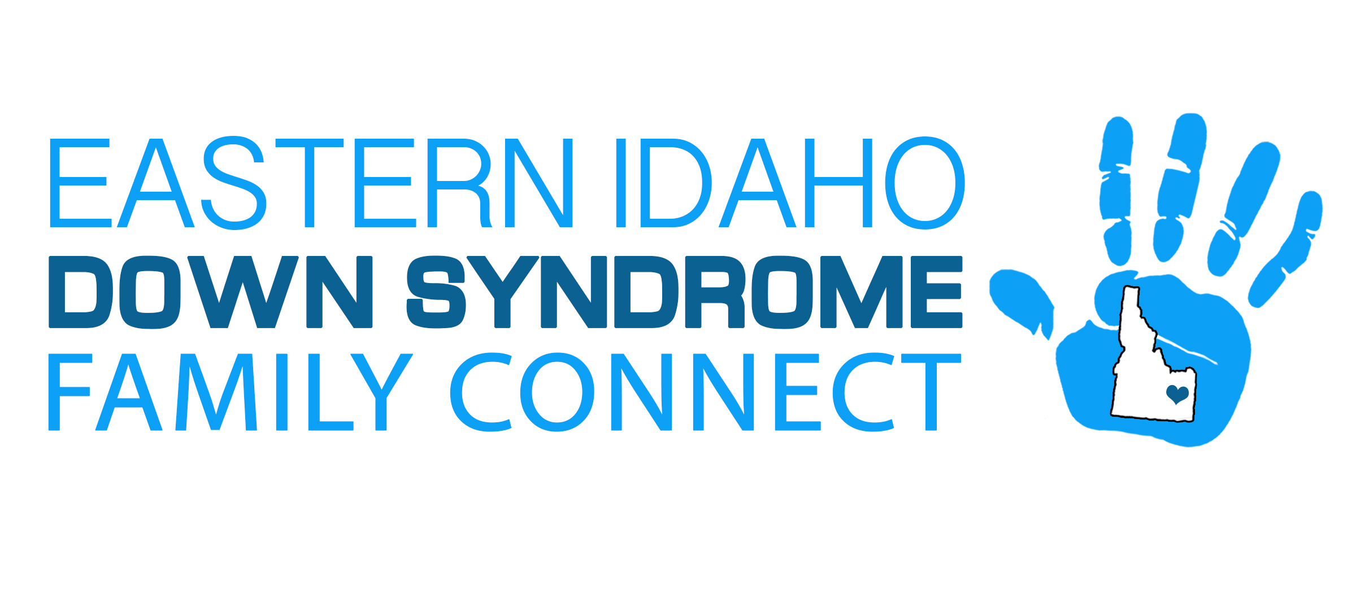
CONFLICT OF INTEREST ACKNOWLEDGEMENT/DISCLOSURE FORM FOR EIDSFC
- CONFLICTING ORGANIZATIONS
I am a director, trustee, officer, representative of, or have a Financial Interest in the following organizations that have or may have a conflict with the interests of the EIDS.
Organization and Title or Interest:
- CONFLICTING ACTIVITIES/OBLIGATIONS
I am involved in no activity or transaction, nor am I a party to any contract involving interests that are or could be found to be adverse to the EIDS except for the following:
- CONFLICTING BUSINESS OPPORTUNITIES/COMMITMENTS
I have not committed to, nor am I pursuing, any business opportunity that does or might adversely affect the EIDS except for the following:
- CONFLICTING RELATIONSHIPS
I do not have a Fiduciary Relationship with any person with whom EIDS is pursuing a business opportunity except for the following:
- OTHER POTENTIAL CONFLICTS
Any other concerns I may have regarding actual or potential conflicts of interest are listed below:
I have received and reviewed EIDS Conflict of Interest Policy, and to the best of my knowledge, I have accurately answered the above questions.
Signature and Date
Printed Name
_____________________________________________

