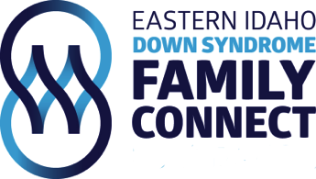
Board of Resolution form
The Board of Directors of Eastern Idaho Down Syndrome Family Connect has reviewed and discussed the Charities Review council's Accountability Standards and acknowledges that and adherence to the standards will benefit EIDS and the donor public by demonstrating the values and public disclosure, responsible governance, sound financial management and ethical fundraising.
The board pledges to continually strive to meet the accountability standards.
Board President:____________________________________ Date:_____________________ Signature:______________________________________________________

