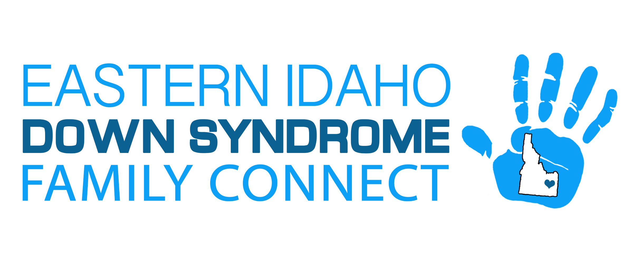
Articles of Incorporation of Eastern Idaho Down Syndrome Family Connect
The undersigned, in order to form a Non-Profit Corporation under the provisions of Title 30 Chapter 3, Idaho Code, submits the following articles of incorporation to the Secretary of State.
Article 1:The name of the Corporation shall be: Eastern Idaho Down Syndrome Family Connect, Inc. (also doing business under the trade name: EIDS or EIDSFC). The duration of the organization shall be perpetual and there will be no voting.
Article 2: The principal office of EIDSFC is to be located at 4114 East 230 North, Rigby, Idaho 83442 (in Jefferson County) AND the registered agent for service of process shall be ROCHELLE LARSEN located at 4114 East 230 North, Rigby, Idaho 83442.
Article 3: EIDSFC is organized exclusively for charitable purposes, including, for such purposes, the making of distributions to organizations that qualify as exempt organization under section 501 ( c ) (3) of the Internal Revenue code, or the corresponding section of any future federal tax code; specifically the purpose of this non-profit corporation is to provide individuals with Down syndrome and their families with the opportunity to achieve their full potential; to encourage and support their participation in community life to promote positive awareness of Down syndrome; to advocate on behalf of individuals and families with Down syndrome; and to facilitate positive self-esteem in individuals with Down syndrome. Furthermore, the organization will provide networking opportunities for individuals living with down syndrome and their families with a particular focus in the Eastern Idaho counties of Bannock, Bingham, Bonneville, Fremont, Jefferson, Madison, and Teton as well as in Teton County, Wyoming.
Article 4:The names of the persons who are the initial trustees of the corporation are as follows:
ROCHELLE LARSEN ERIC LARSEN ANGELA MAGO KAREN HUNT AMY ELISON MARY MURRAY

Article 5:The board of directors shall consist of no fewer than three (3) people. The names of the initial board of directors are:
ROCHELLE LARSEN ERIC LARSEN
ANGELA MAGO MARY MURRAY KAREN HUNT
AMY ELISON

Article 6: The name(s) and address(es) of the incorporators are:
ROCHELLE LARSEN ERIC LARSEN 4114 E 230 N RIGBY, ID 83442
Article 7: No part of the net earnings of the corporation shall inure to the benefit of, or be distributable to its members, trustees, officers, or other private persons, except that EIDS shall be authorized and empowered to pay reasonable compensation for services rendered and to make payments and distributions in furtherance of the purpose set forth in Article Third hereof. No substantial part of the activities of the corporation shall be the carrying on of propaganda, or otherwise attempting to influence legislation, and EIDS shall not participate in, or intervene in (including the publishing or distribution of statements) any political campaign on behalf of or in opposition to any candidate for public office. Notwithstanding any other provision of these articles, the corporation shall not carry on any other activities not permitted on (a) by a corporation exempt from federal income tax under section 501 ( c ) (3) of the Internal Revenue Code, or the corresponding section of any future federal tax code, or (b) by a corporation, contributions to which are deductible under section 170 ( c ) (2) of the Internal Revenue Code, or the corresponding section of any future federal tax code. Notwithstanding any other provisions of these articles, this corporation shall not, except to an insubstantial degree, engage in any activities or exercise any powers that are not furtherance of the purposes of this corporations.
Article 8: Upon the dissolution of EIDS, assets shall be distributed for one or more exempt purposes within the meaning of section 501 ( c ) (3) of the Internal Revenue Code, or the corresponding section of any future federal tax code, or shall be distributed to the federal government, or to a state or local government, for a public purpose. Any such assets not so disposed of shall be disposed of by a Court of Competent Jurisdiction of the county in which the principal office of the corporation is then located, exclusively for such purposes or to such organization or organizations, as said Court shall determine, which are organized and operated exclusively for such purposes.
Article 9: Provisions for the regulation of the internal affairs of EIDS shall be set forth in the Bylaws of the Corporation as may be adopted by its incorporator(s) or board of directors.
Article 10:These Articles of Incorporation may be amended at any time by written instrument signed and sealed by the Board of Directors, provided that no amendment shall authorize the trustees, board of directors, officers, or affiliate of EIDS to conduct the affairs of EIDS in any manner or for any purpose contrary to the provisions of section 501 ( c ) (3) of the Internal Revenue Code, or the corresponding section of any future federal tax code.
Signatures of all Incorporators:
_________________________________
ROCHELLE LARSEN
_________________________________
ERIC LARSEN
_________________________________
ANGELA MAGO
_________________________________
MARY MURRAY
_________________________________
KAREN HUNT
_________________________________
AMY ELISON

